**CS551 – MIDTERM**

**Poojitha Mittapally,**

**16157740**

**Design:**

**Class diagram:**

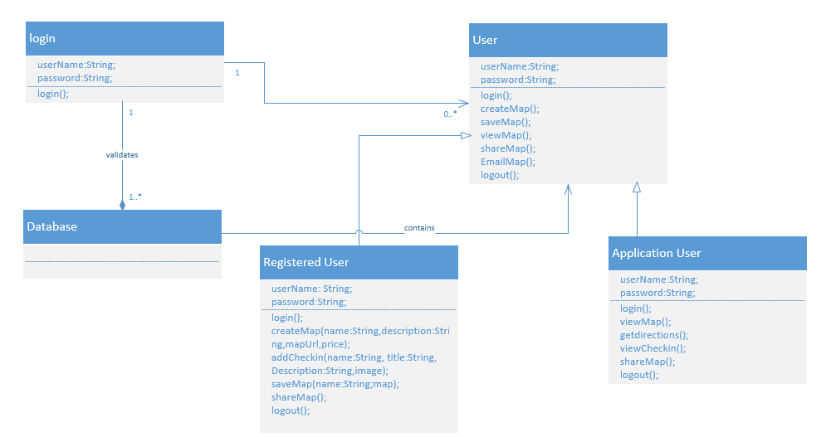

**Fig. Class Diagram of TripBuzz**

**Features Implemented:**

* Login
* Register
* Image Slider
* Create a map.
* View maps stored in Routes shop.
* Share the map with others through social networking sites.
* Logout

**Existing Web service/API:**

I have used API for the map creation.

The API used in TripBuzz is from Scribble Maps API. It is <https://scribblemaps.com/jsapi/>

**Database**

I have used “MSSQL server database” for my application to store map data like Name, Description, Price, Map URL, etc.

**Screenshots of TripBuzz:**

This is the home page of TripBuzz.

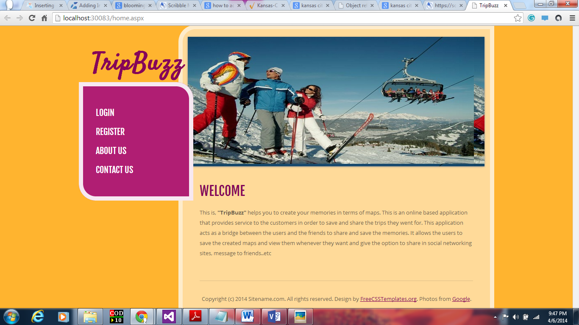

**Fig . Screenshot of Home Page**

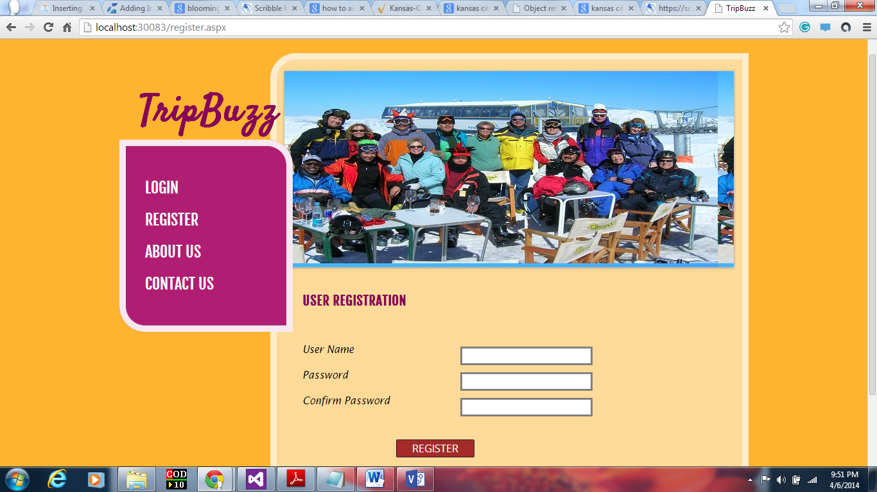

**Fig . Screenshot of Registration Page**

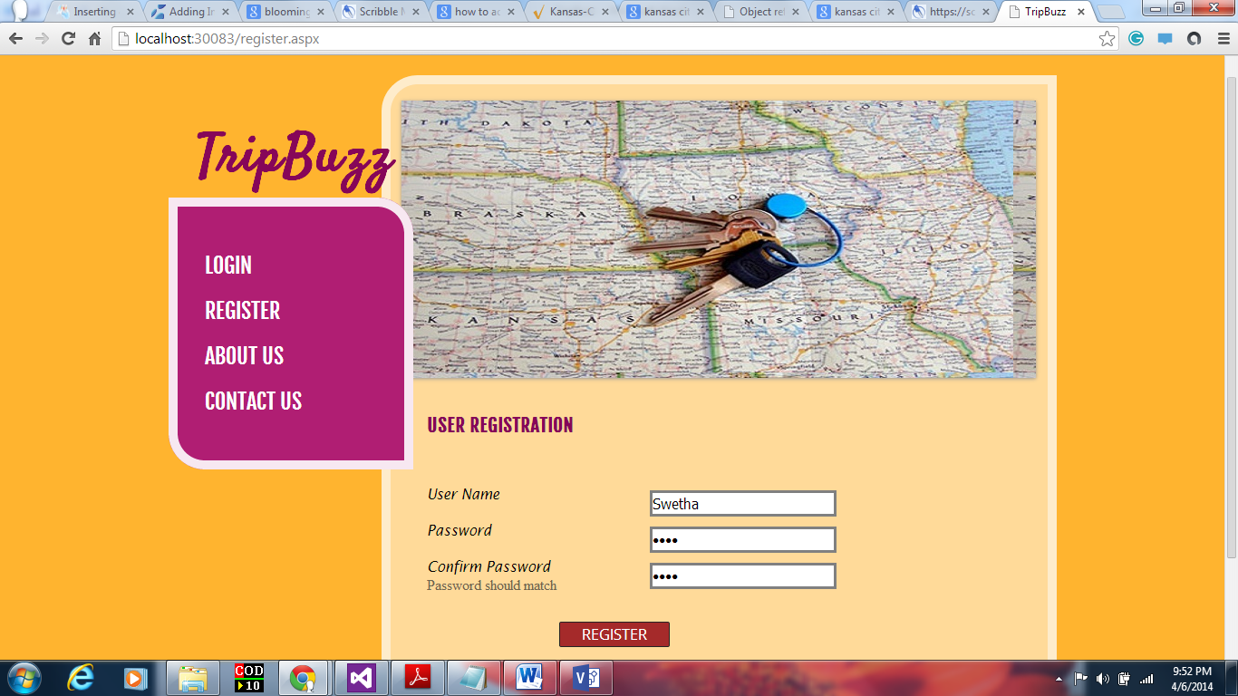

**Fig. Password should match.**

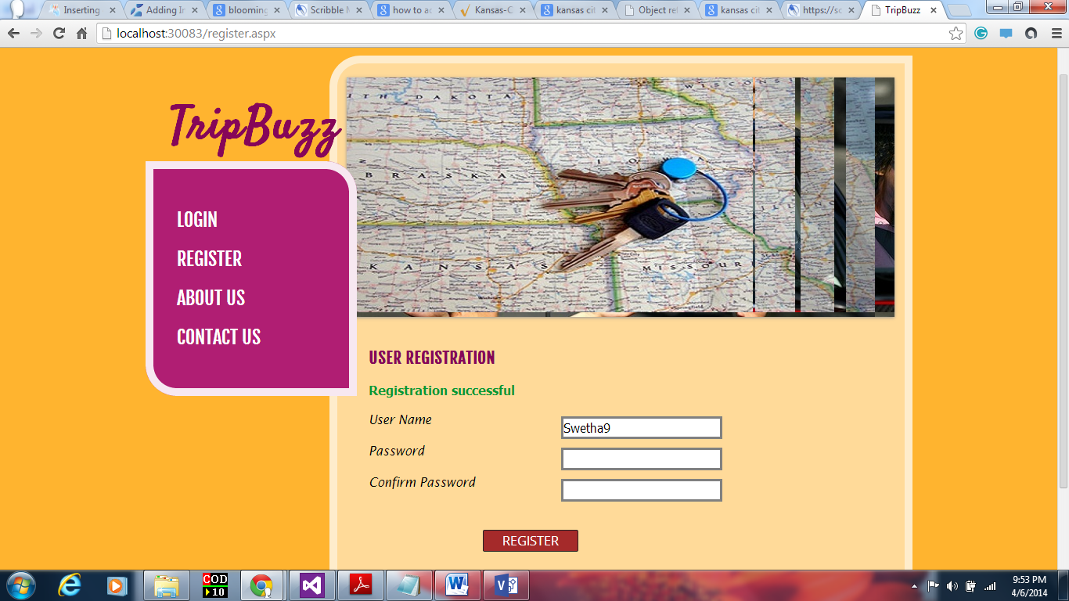

**Fig. Registration successful page**

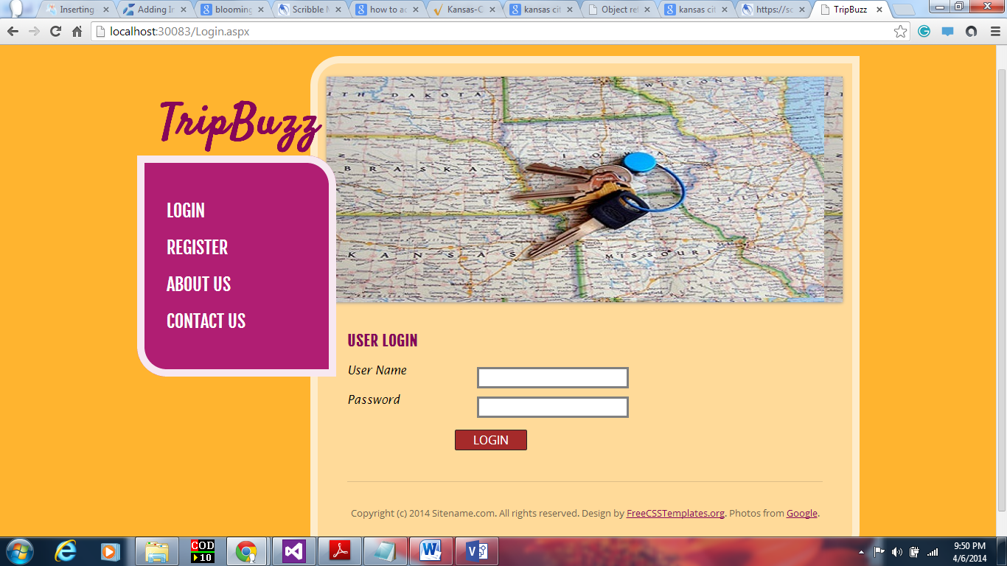

**Fig . Screenshot of Login Page**

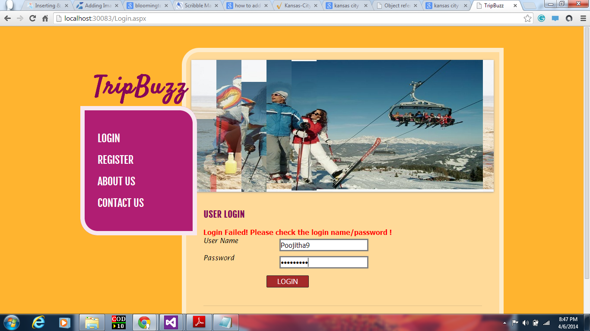

**Fig. Login Fail**

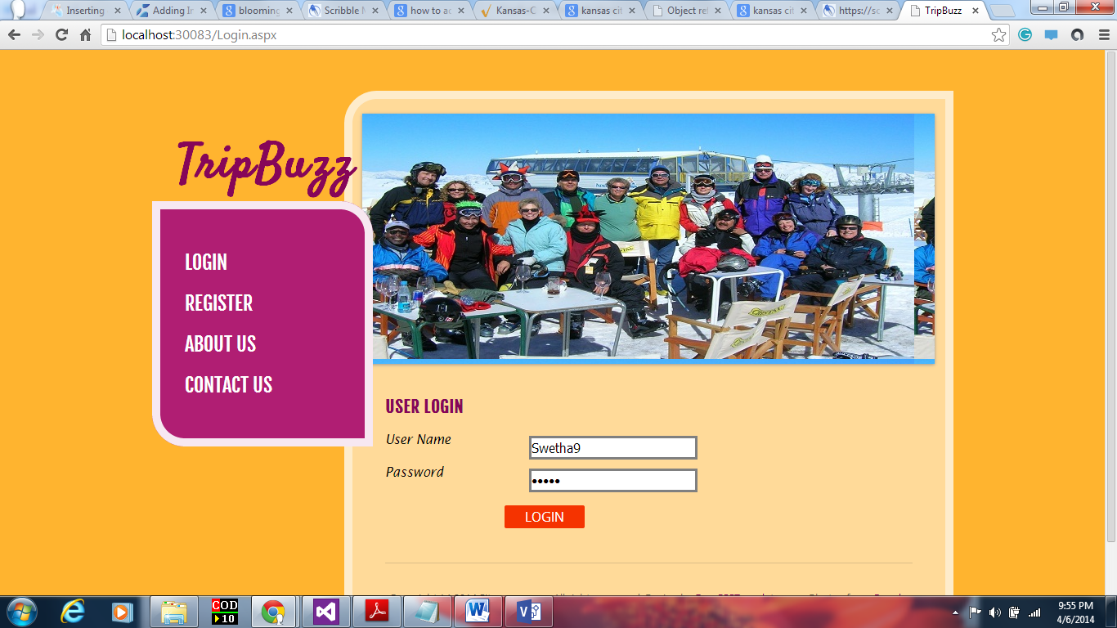

**Fig. Screenshot of user login**

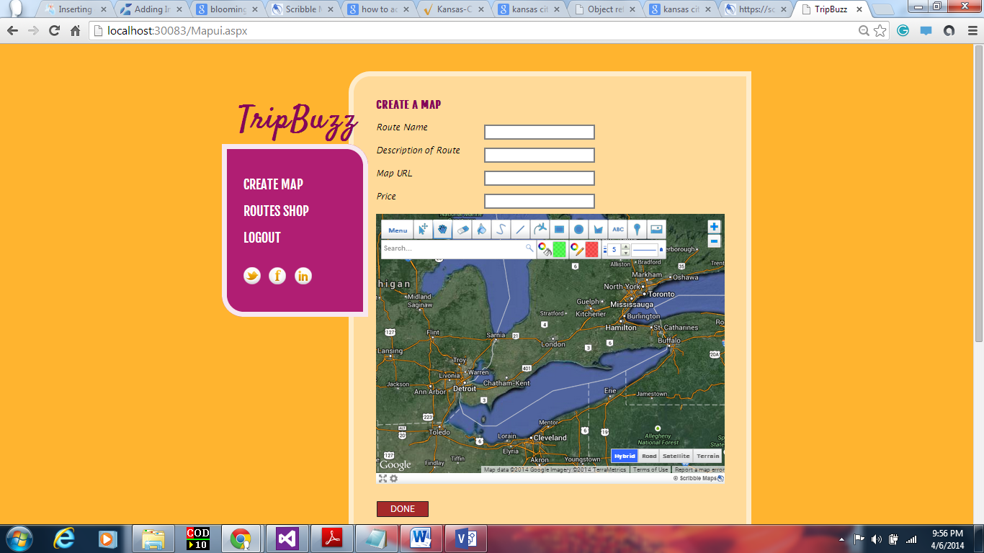

**Fig. User page.**

**Here the user should add check-in by clicking on marker symbol. They need to add a title, description, image and also note them in check-in columns and click on check-in.**

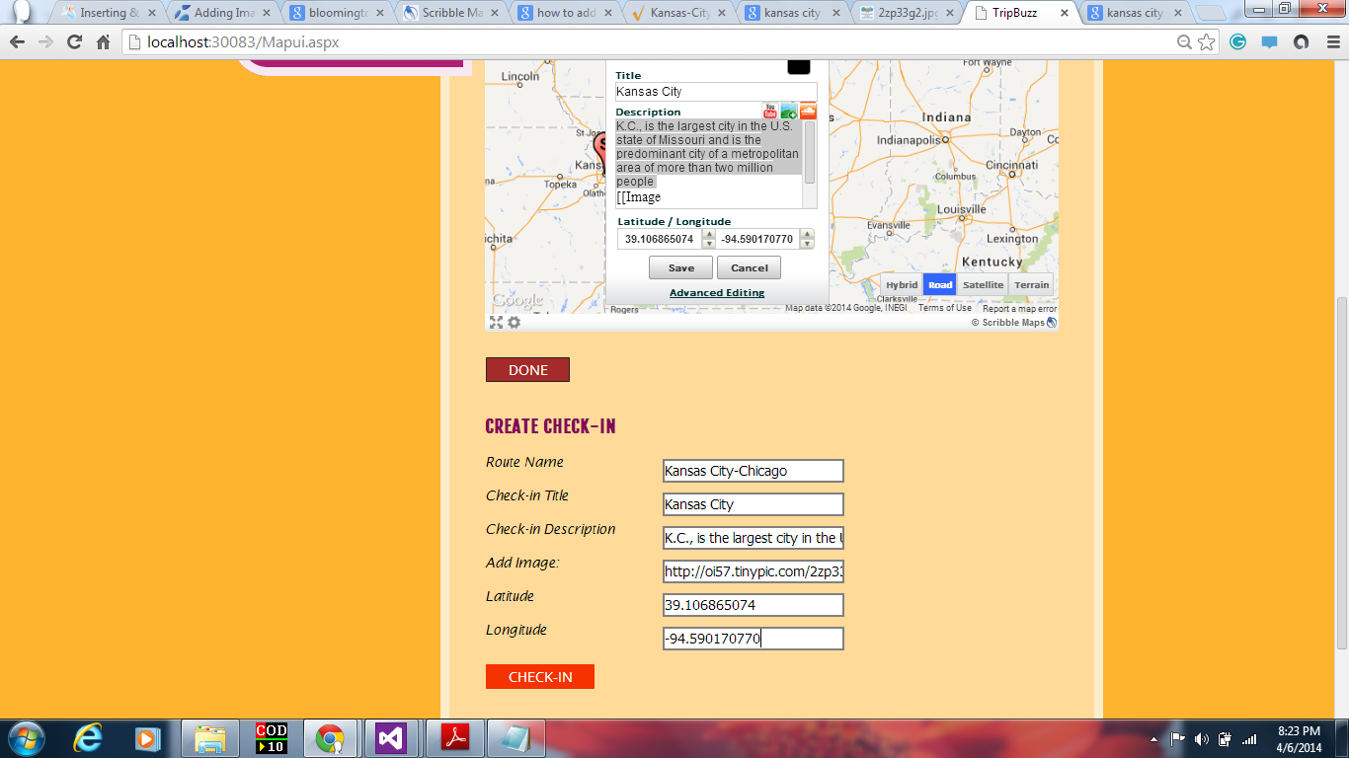

**Fig. Adding Check-in**

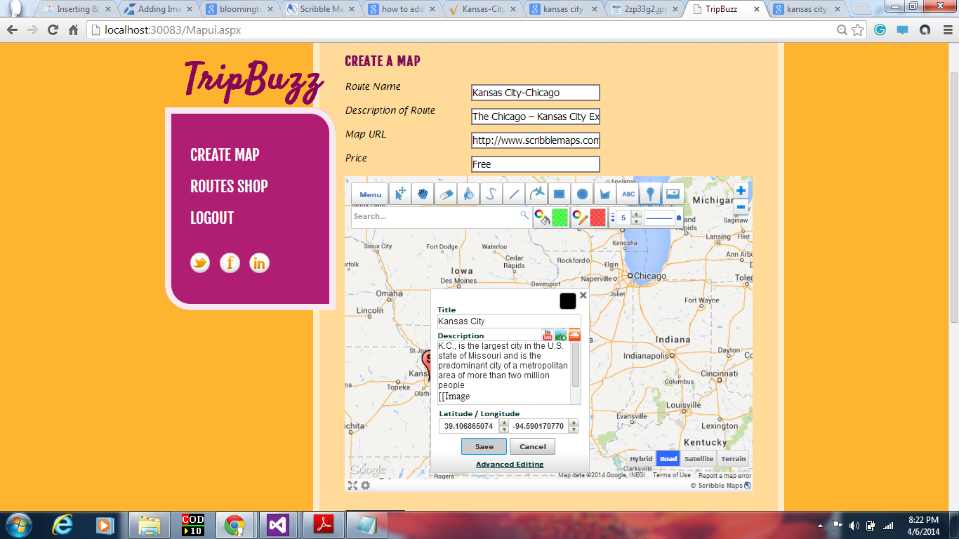

**Fig. Creating map, adding title and description to the Check-in.**

**Image is added to check-in with url and click on import.**

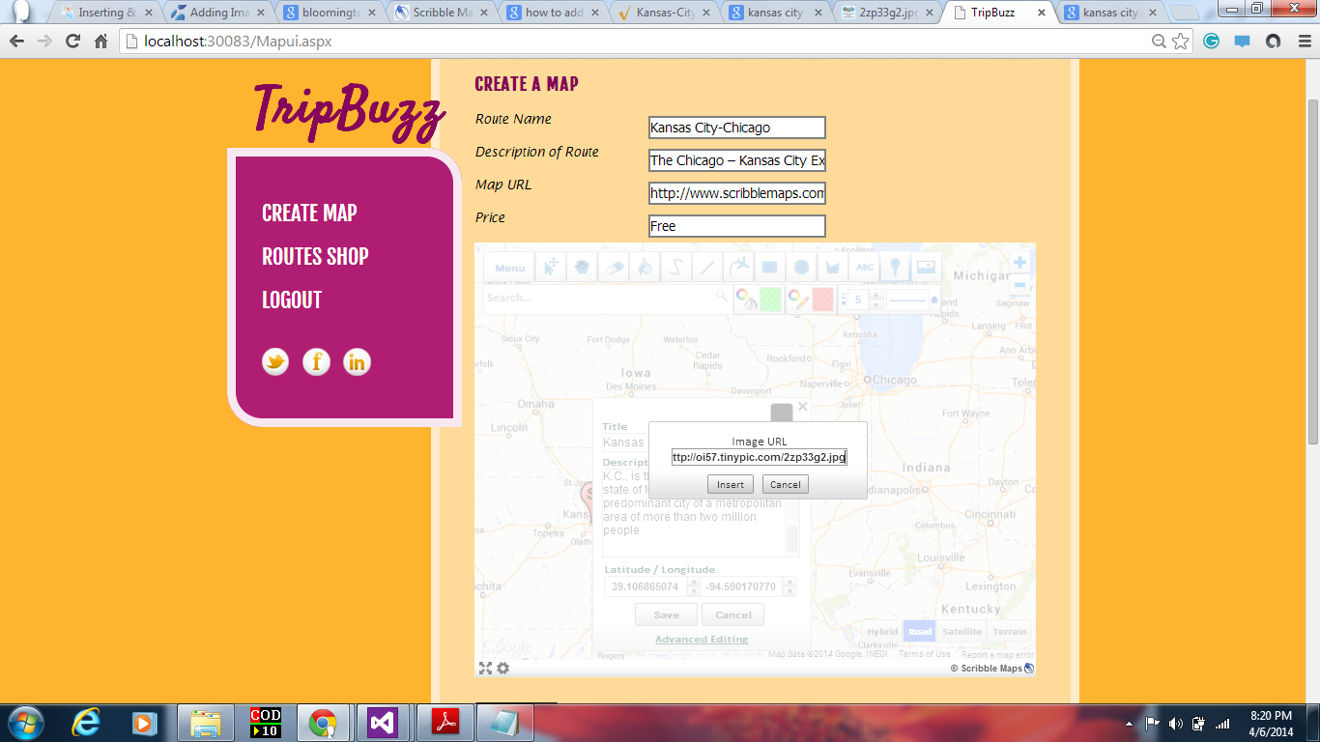

**Fig. Adding Image URL to Check-in.**

Map is created upon clicking Done.

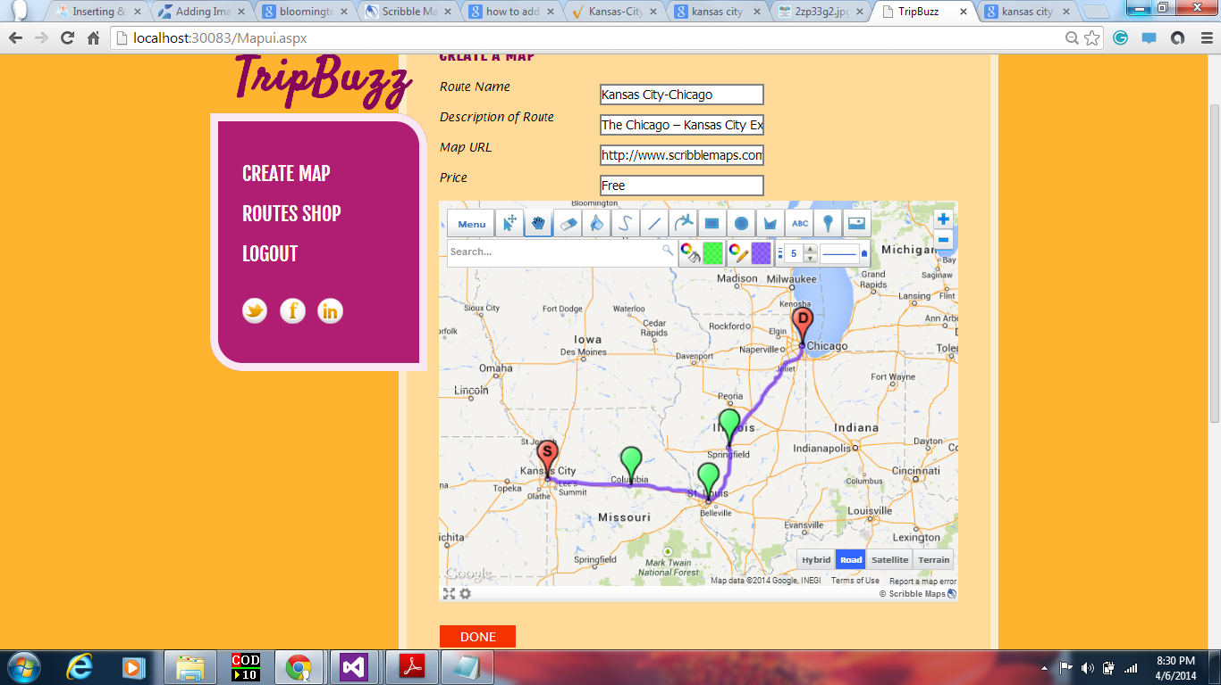

**Fig. Map is created.**

**This is routes shop that displays the created map in the previous screenshot.**

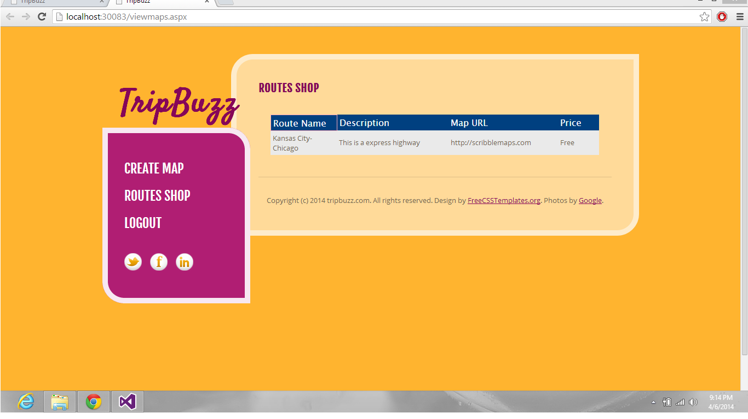

**Fig. Routes Shop shows saved routes.**

**Upon clicking the map url, the page will be redirected to “Walk through the Map” page as shown below.**

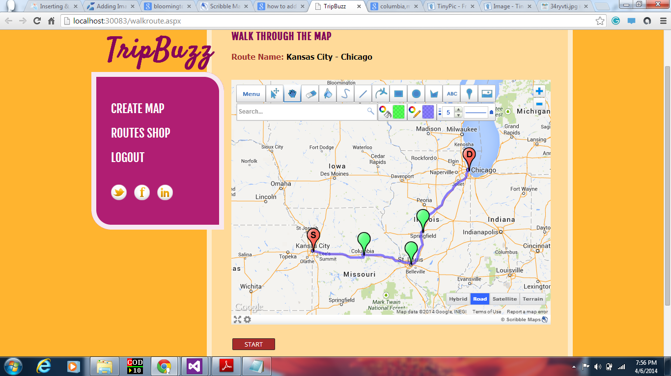

**Fig. Walk through the map.**

**The start button will redirect the map to the source.**

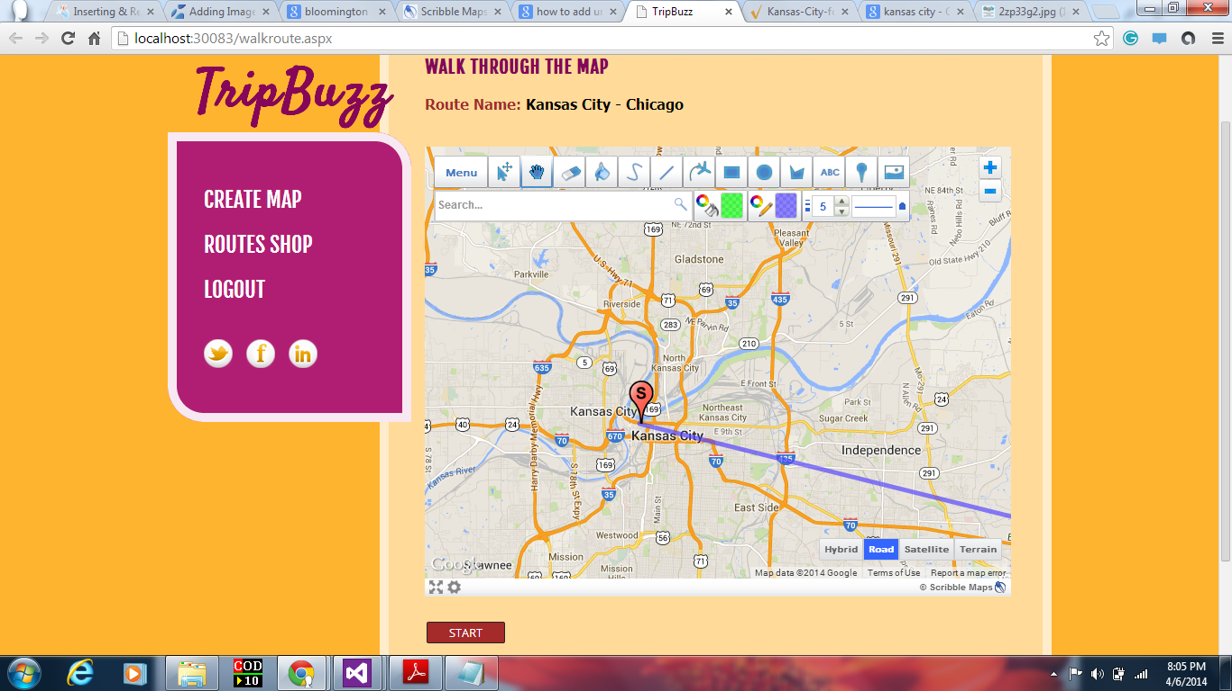

**Fig. Start button redirects to source marker.**

**Upon clicking the check-in, it shows the image, title and description that is saved when creating check-in.**

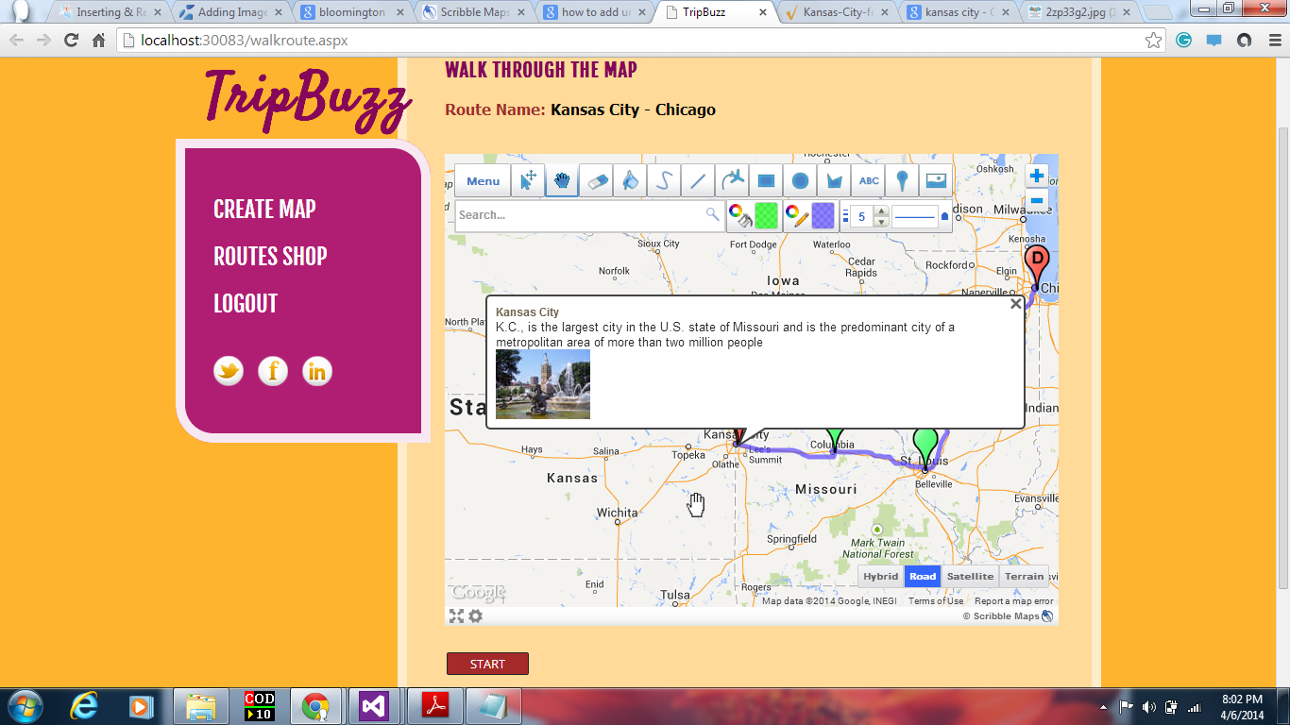

**Fig. Check-in upon click, displays Title, Description and Image.**

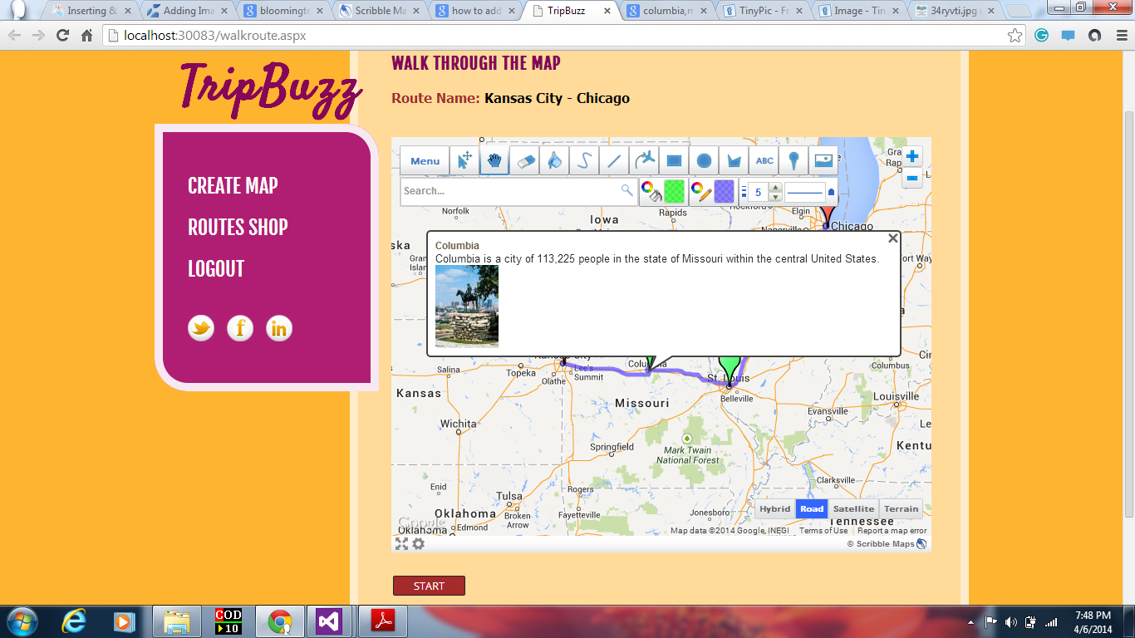

**Fig. Check-in Columbia with description and image.**

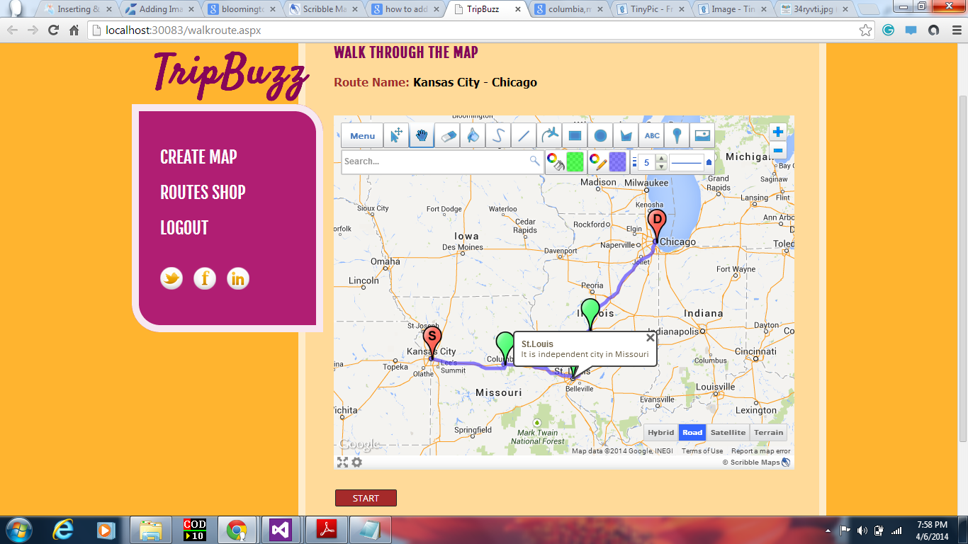

**Fig: Check-in showing Title, Description**

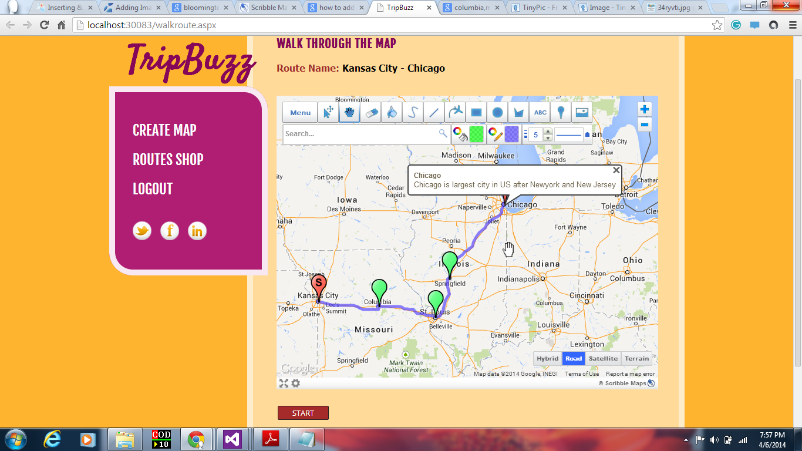

**Fig.Check-in showing Title, Description.**

**The Menu option on map, will allow the user to share the map through email.**

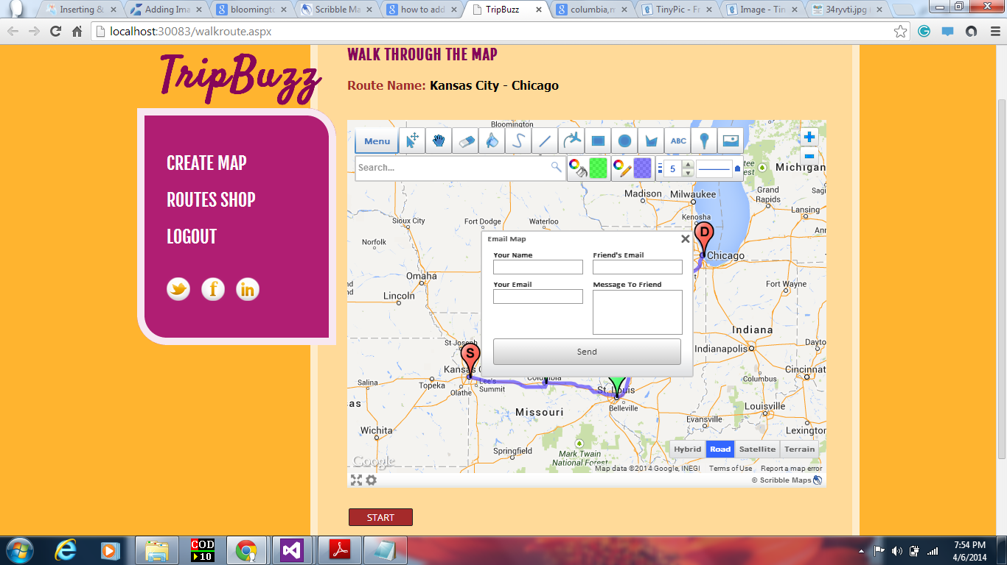

**Fig. Map share with a friend through Email.**

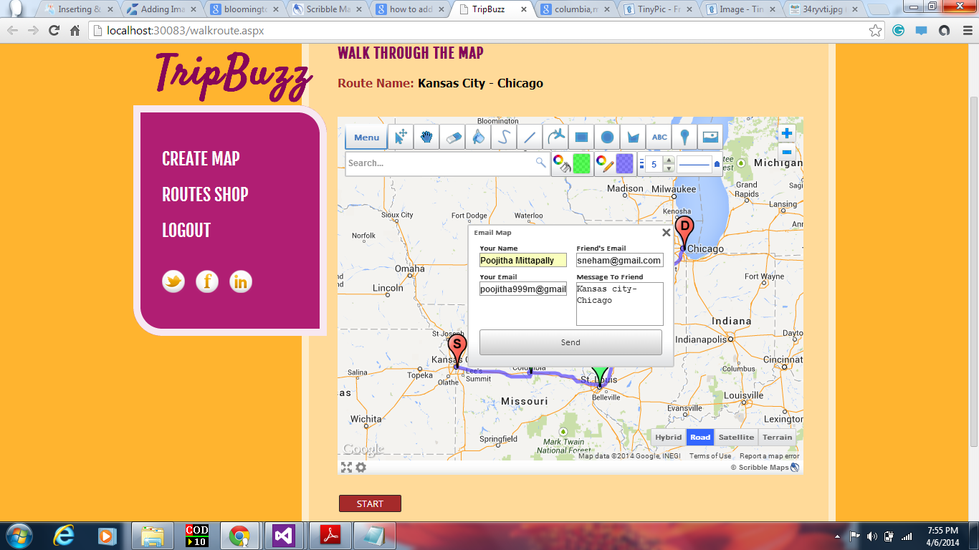

**Fig. Map sharing through Email.**

**Social icons to the left side, allow users to share the map with friends through Facebook, Twitter and Linkedin.**

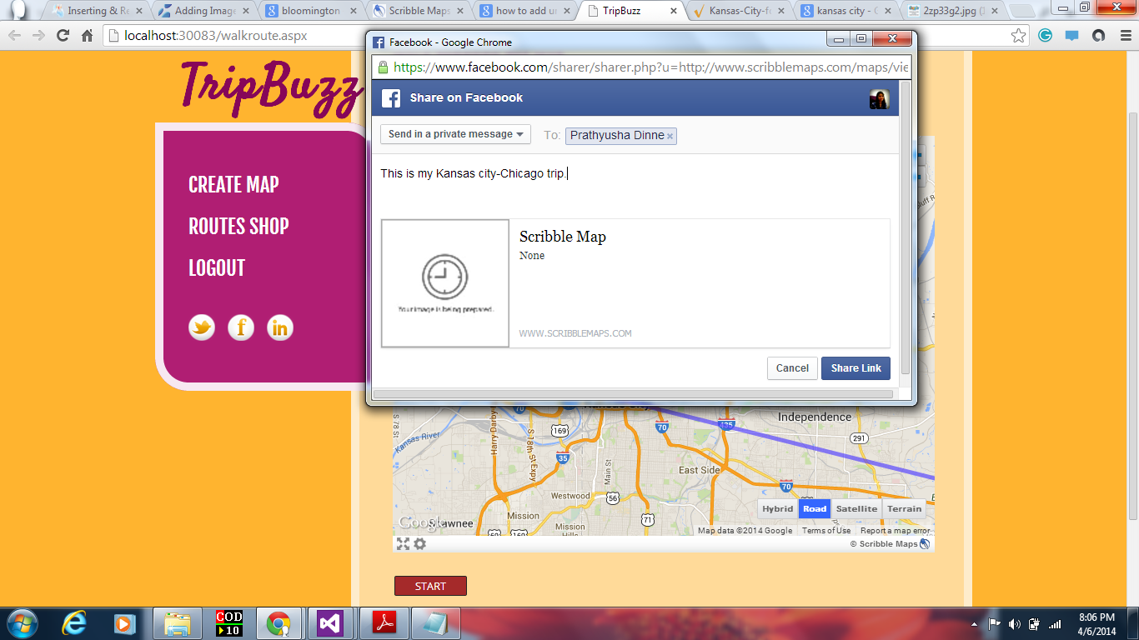

**Fig. Sharing the map through Facebook to a friend.**

**This is about us page.**

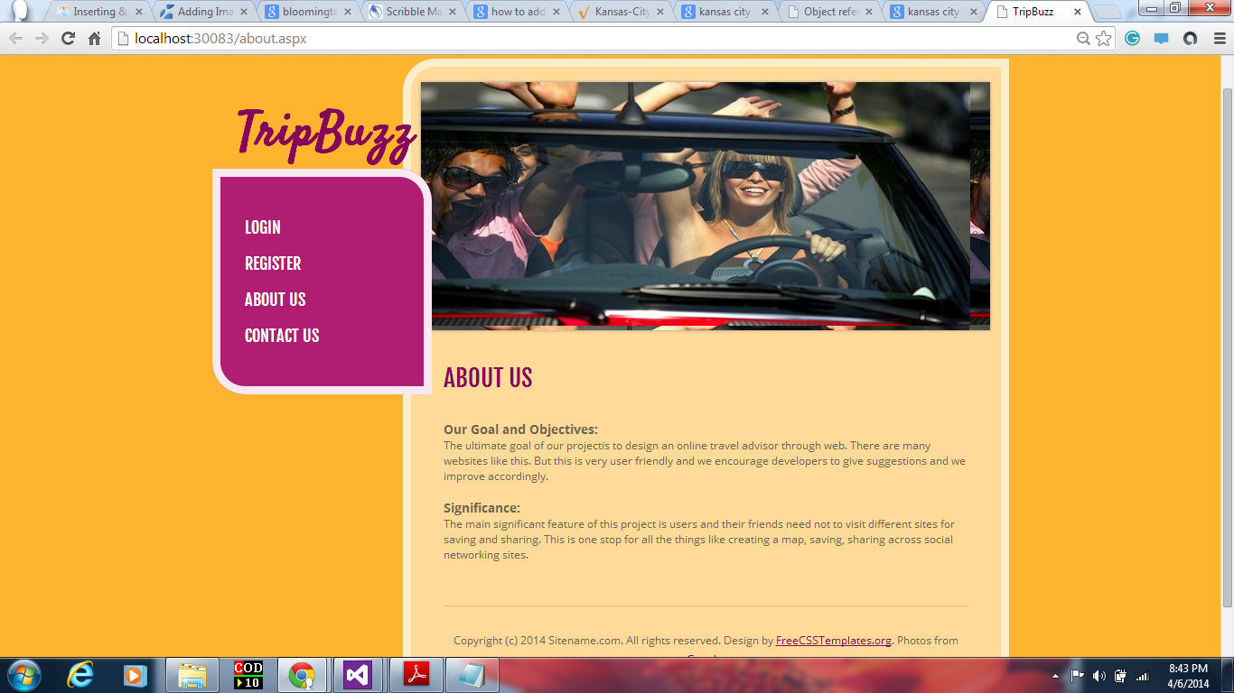**Fig. About us page.**

**This is contact us page.**

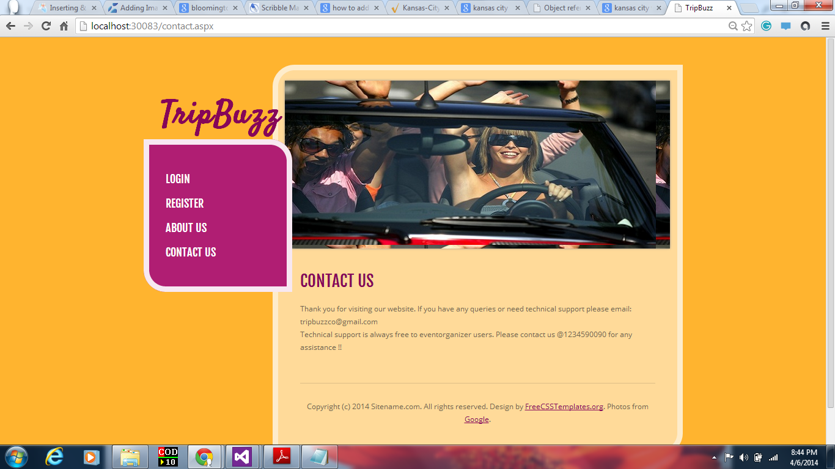

**Fig. Contact us page**

**Webservice and website URL’s:**

1. URL of TripBuzz: <http://localhost:30083/home.aspx>

**Github URL:** <https://github.com/pmhfb/Midterm>/

**References:**

* [**https://www.google.com/**](https://www.google.com/)
* [**http://www.scribblemaps.com/**](http://www.scribblemaps.com/)
* [**http://www.scribblemaps.com/jsapi/**](http://www.scribblemaps.com/jsapi/)
* [**http://www.freecsstemplates.org/**](http://www.freecsstemplates.org/)
* [**https://developers.facebook.com/docs/plugins/share-button/**](https://developers.facebook.com/docs/plugins/share-button/)
* [**https://dev.twitter.com/docs/tweet-button/**](https://dev.twitter.com/docs/tweet-button/)